**Lab 8 Report**

**LAB 8: Accessibility in UX Design**

**Name: Hamza Mehmood**

**Class & Section: BS-SE 6TH (Evening)**

**Roll number: SP-21-110**

**Assigned Design: E-Commerce Design**

**Task Assessment:** Review and analyze accessibility guidelines and standards relevant to their target platform or context. They will then design and implement accessibility features in a website or app, incorporating the recommended accessibility techniques.

Do attach screenshots with respective Link

**Version 1:** [Hamza_Mehmood-CarMania – Figma](https://www.figma.com/file/4K2Z8IyRLtXlC1Gf47wm6C/Hamza_Mehmood-CarMania?type=design&node-id=1-32&mode=design&t=RZY5vd1j2uCAF9Jf-0)

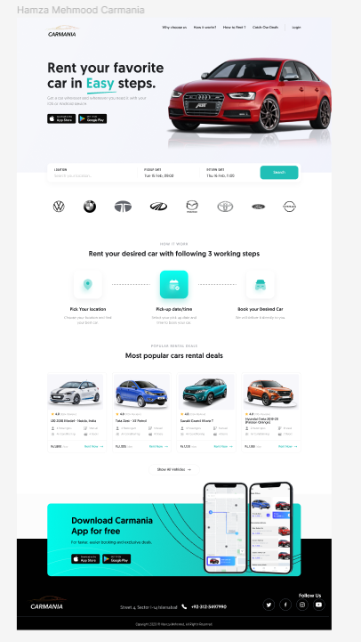

Page **1** of **2**

**Evaluating Recommendations:**

* The cyan color is difficult for color blindness people so replacing it.
* The car description font is too small.
* Changing color of Main Headline.
* Making Footer easily readable for colorblind people.

Do attach screenshots.

**Version 2:**

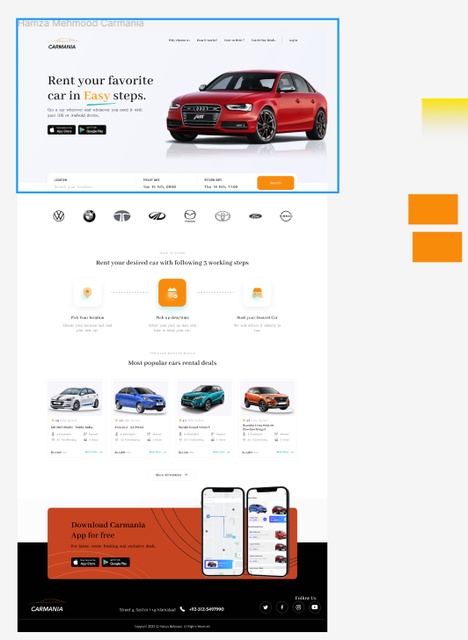

Page **2** of **2**